
CENTRAL WEST EDUCATION DIVISION
2026 MALAWI SCHOOL CERTIFICATE OF EDUCATION
MOCK EXAMINATIONS
MATHEMATICS
PAPER I
Wednesday, 25th March (100 Marks) Subject Number: M131/I
Time Allowed: 2 hours 08:00 - 10:00 am

Instructions:
- This paper contains 13 printed pages. Please check.
- Write your CANDIDATE NUMBER and SCHOOL on each page.
- Answer all questions.
- Write your answers in the spaces provided on the question paper.
- Calculators may be used.
- Your working must be clearly shown.

Questions  Answered | Tick if  Answered | Do not write in this column
1
2
3
4
5
6
7
8
9
10
11
12
13
14
15
16
17
18
19
20
Total

- Factorise ${2r}^{3}-{mr}^{2}-3m^{2}r.$ (4 marks)

- Simplify $\frac{4}{8-2\sqrt{6}}$ leaving the answer with rational denominator. (4 marks)

- Make $y$ the subject of the formula given $x^{\sqrt{bx}}=y^{\frac{x}{2}}$. (5 marks)

- Given that the $y-$ intercept of the line joining $A(t,t+2)$ and $B(3t,5t+2)$ is $-1$, calculate the value of $t$. (4 marks)

- Given that the area of a figure is 16 times the area of a smaller similar figure. If the height of bigger figure is 32cm, calculate the height of the smaller figure. (4 marks)

- Given that the function $f\left(x\right)=\sqrt{ax+b}$ is defined for $x>\frac{1}{2}$. If $f\left(5\right)=3$and $f\left(8\frac{1}{2}\right)=4,$ calculate the values of $a$ and $b$. (6 marks)

- In a geometric progression, the sum of the first $n$ terms is given by $S_{n}=8-2^{3-n}$. Find the first term and the common ratio. (5 marks)

- Figure 1 shows a grid with vectors,
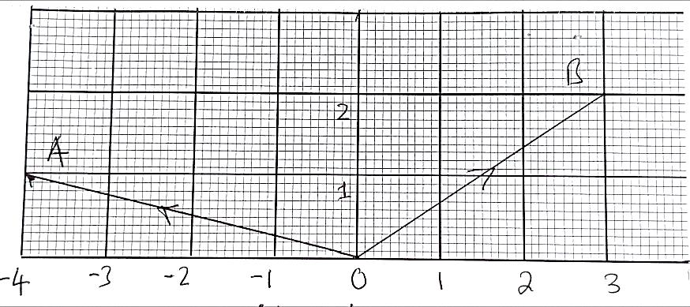

Figure 1
Calculate $\left|\overset{→}{AB}\right|$ in simplified surd form. (5 marks)

- Given that $M=\left[\begin{matrix}-2 & 0 \\ 1 & -1\end{matrix}\right], N=\left[\begin{matrix}-1 & 2 \\ 3 & 1\end{matrix}\right]$ find matrix L such that $2L+M^{2}=4N$. (5 marks)

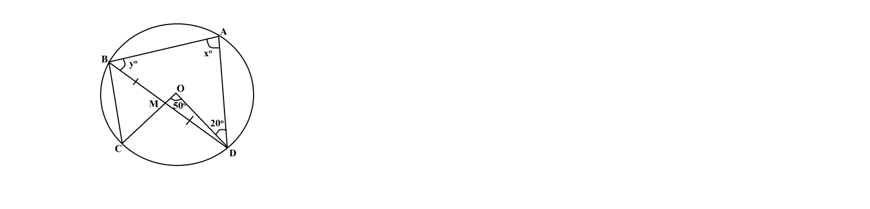
- Figure 2 shows a circle ABCD with centre O. Angle ODA = 20º, COD = 50º, BM = MD, angle ABM = yº and angle BAD = xº.

Figure 2
Calculate the size of x and y. (6 marks)

- Given that the mean scores: $2a+1. 3a. 9a-3$ and $a$ have the mean of $3a+1$, find the value of $a$. (4 marks)

- Solve the equation $1={3x}^{2}-7x$ correct to 2 decimal places. (6 marks)

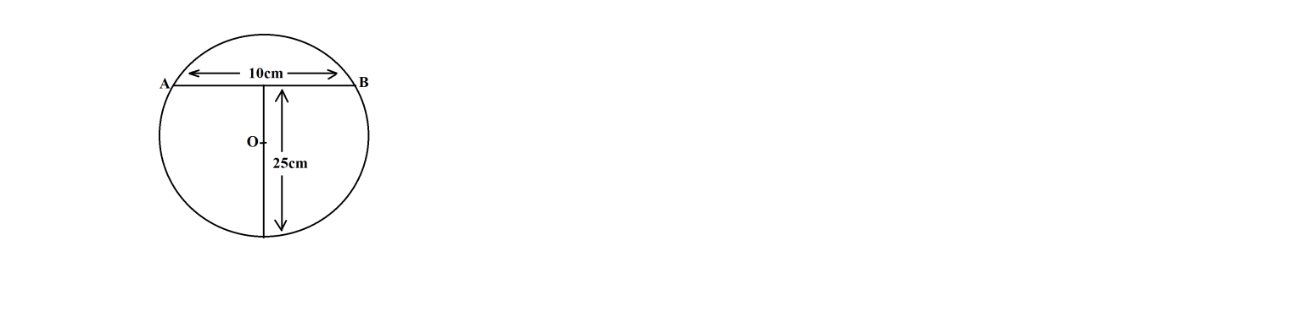
- Figure 3 shows a logo designed in a circle with symmetrical T – shape of height 25 cm and a cross – piece AB of length 10 cm.

Figure 3
Calculate the radius of the circle. (5 marks)

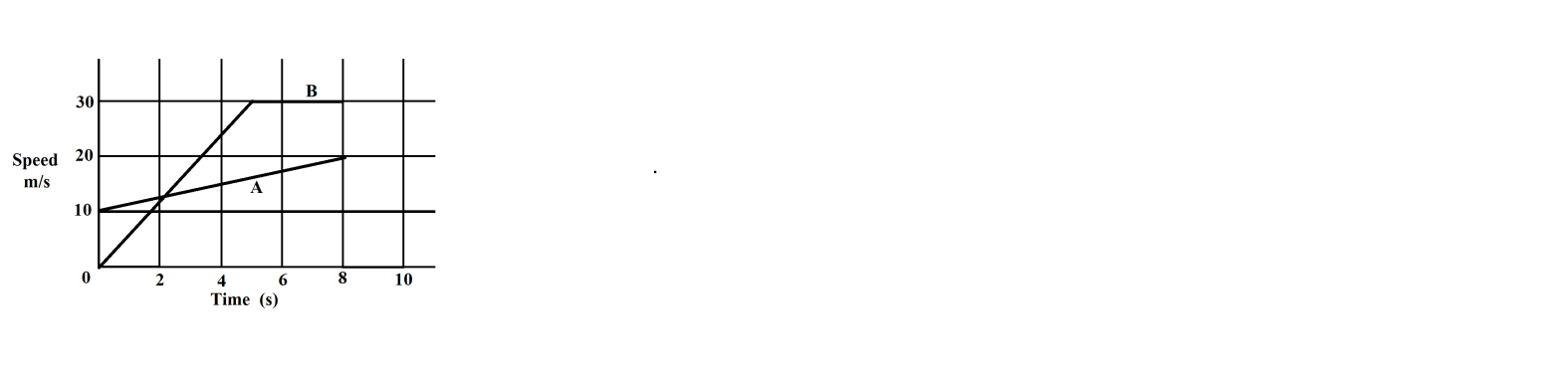
- Figure 4 shows travel graphs for bodies A and B.

Figure 4
Calculate the distance covered by bodies A and B in the 8 seconds. (5 marks)

- Given that the polynomial ${3x}^{2}+12x+5=P{\left(x+q\right)}^{2}+r$, find the values of $p,q and r$. (5 marks)

- A quadrilateral ABCD is such that A, B, C, D have coordinates (- 4,6), (2,9), (2,3) and (- 4,0) respectively. Its image under enlargement has vertices A’ (6,4), B’ (8,5), C’ (8,3) and D’ (6,2).
- On the grid provided on page 10 draw the quadrilateral ABCD and its image A’B’C’D’. (3 marks)

- Find the:
- Coordinates of the centre of enlargement. (2 marks)

- Scale factor of enlargement. (1 mark)

- Given that the height $h$ of a cylinder varies as its volume,$V$ and inversely as the square of its radius, r cm. the volume of a cylinder with radius 3cm and height 14cm is 132 cm³, find the radius of the cylinder with volume of 616 cm³ and height 12 cm. (5 marks)

- On the same axes, draw the graphs of the following inequalities to show region R, shade the unwanted region. $2>x, y≤4, y≥-2x-2$ and $2y>x$. (5 marks)

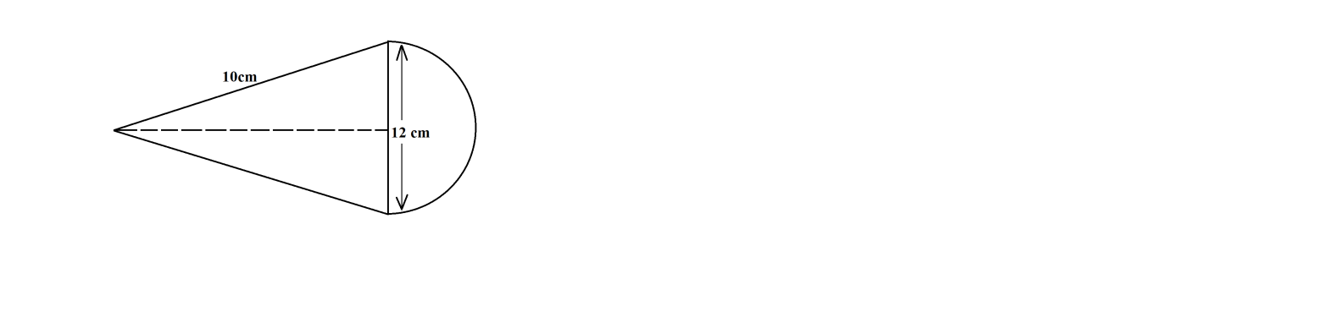
- Figure 5 shows a metal solid made of a cone joined to a hemisphere. The diameter is 12 cm and the slant height of the cone is 10 cm.

Figure 5
If the object is melted and recast into a solid cylinder of height 15 cm and radius r cm, calculate the radius of the cylinder assuming there is no loss of metallic material. Volume of cone $=\frac{1}{3}πr^{2}h$, volume of sphere $=\frac{4}{3}{πr}^{3}$. (6 marks)

- A plane is flying at an altitude of 6 km directly above a sea. It sports two boats A and B at angles of depression of 60º and 30º respectively. Calculate the horizontal distance between the two boats, correct to 2 decimal places. (5 marks)

END OF QUESTION PAPER

